

**Alexander Thomas List, Andrea List – 2011**

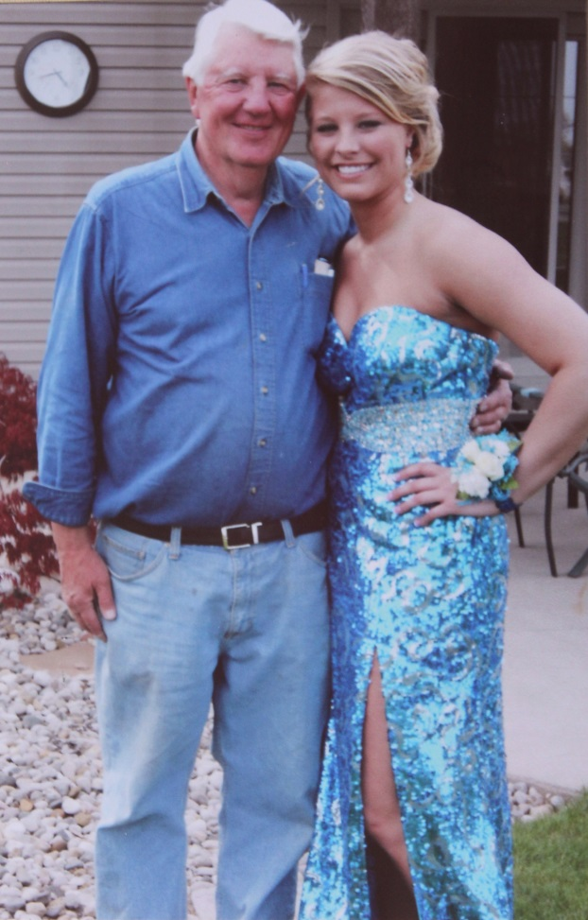

**David Wolfe List and granddaughter, Andrea Briann List – 2012**